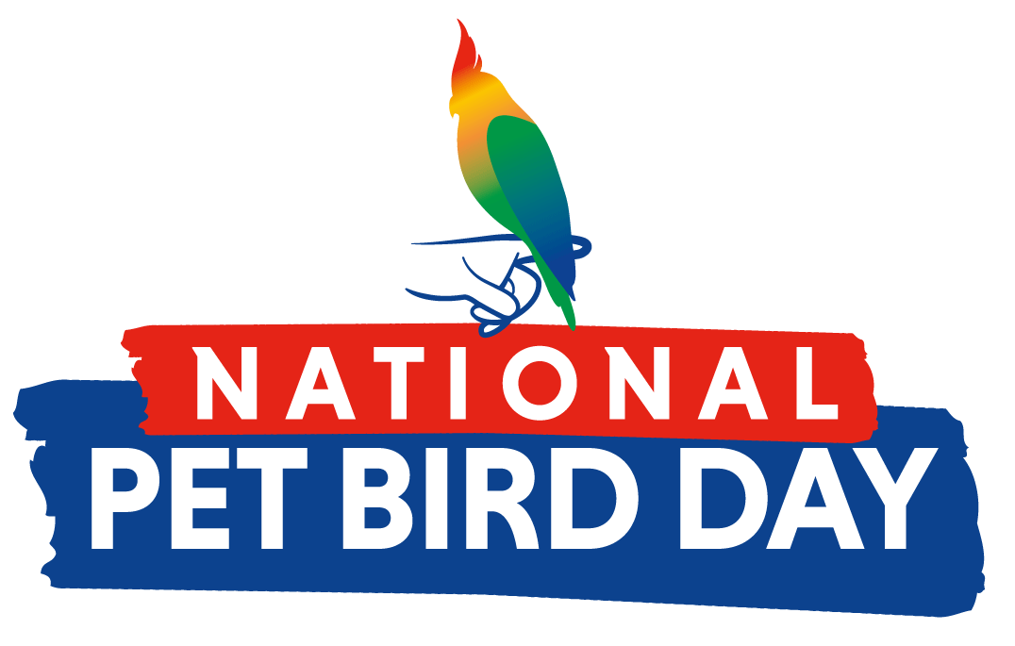

FOR IMMEDIATE RELEASE Contact: Cindy Woudenberg
Tel: 602-363-5054
cindy@lucorpmarketing.com

National Pet Bird Day Celebrates the Joys and Benefits of Pet Bird Ownership
Established by the Bird Enjoyment & Advantage Koalition (BEAK), National Pet Bird Day is held on September 17 each year.

The Bird Enjoyment & Advantage Koalition (BEAK), a group of bird product manufacturers and associations formed to address the need for responsible bird ownership and growth, is pleased to announce that the 5th Annual National Pet Bird Day will take place on September 17, 2023. Created as an opportunity to celebrate the many ways in which pet birds enrich their owners’ lives, this special day also aims to educate the public about the responsibilities and commitments that come with having a companion bird.

“Birds are amazing companion animals and are actually very connected to their owners,” said Brent Weinmann, BEAK Chairman. “National Pet Bird Day serves as a day to celebrate all the benefits that pet birds bring to our lives, educate on responsible bird ownership and encourage others to consider adding a feathered family member to their flock.”

BEAK, along with its public-facing marketing campaign, MyBird, encourages pet bird owners and enthusiasts to celebrate National Pet Bird Day in many different ways. For instance, the organization is excited to sponsor a video contest for the second consecutive year. Called “My Beautiful Pet Bird,” the contest will invite bird owners to submit short videos showcasing what makes their pets so special. People will be asked to vote for their favorite videos, and prizes of up to $500 will be awarded to the videos that receive the most votes. In addition to the video contest, many of the bird product retailers and manufacturers that comprise BEAK are planning to run special offers, which will be highlighted on MyBird’s social media channels and email campaigns. Bird owners will also be encouraged to join in the fun by sharing stories, photos and videos of their birds on social media using the hashtag #NationalPetBirdDay.

With an estimated 8% of U.S. households (or 9.9 million) now owning pet birds, BEAK and MyBird are excited to continue generating enthusiasm and providing education about these incredible creatures. At the organization’s website, https://myrightbird.com, visitors will find a trove of informative and engaging resources. One of the most popular features is an interactive quiz with a series of questions designed to help match users with the types of birds that may be right for their lifestyle. Quiz questions range from time and financial commitments, living arrangements and noise tolerance, to birds’ level of affection and expected lifespan – all of which are key factors for potential bird owners to consider. Other helpful tools on the site include fact sheets about different birds, as well as locators to help users find birds available for sale or adoption, avian veterinarians, and bird product retailers in their area.

Follow @MyBird on Facebook or @MyRightBird on Instagram for the latest on National Pet Bird Day video contests, special offers, pet bird tips and more! To learn more about National Pet Bird Day, visit www.nationalpetbirdday.com for a downloadable toolkit and other ways to participate.

###

About BEAK
Founded in 2016, the Bird Enjoyment and Advantage Koalition (BEAK) consists of bird product manufacturers, associations and caregivers with shared interests to address the need for increased, responsible bird ownership. BEAK’s mission is to conduct research, identify existing resources, opportunities and challenges, and educate and drive awareness of the benefits of bird ownership through strategic communications, marketing, collaborations and initiatives. www.MyRightBird.com

